Complex Form Building using formik Lib in React

npm install formik

Create a component named as Form3.jsx and add the following code :

import React, { useState } from 'react'
//we have to import useformik hooks from formik lib
import { useFormik } from 'formik'
const Form3 = () => {
const [submitting, setSubmiting]= useState(false);

const formik = useFormik({
//values
initialValues:{
'fname':'',
'lname':'',
'phone':'',
'email':'',
'pass1':'',
'pass2':'',
'languages':[] //To hold the multiple values.
,
'skills':[]
},
onSubmit: (values) => {
console.log(values);
setSubmiting(true);

},
//form validations
validate:(values)=>{

let newErrors = {};

if(!values.fname){
newErrors.fname = "FirstName is Required";

}else if(!/^[a-zA-Z]{3,16}$/.test(values.fname)){
newErrors.fname = 'FirstName cant allow numbers min 3 to max 16 Chars Long';

}
//lastname validations
if(!values.lname){
newErrors.lname = "LastName is Required";

}else if(!/^[a-zA-Z]{3,16}$/.test(values.lname)){
newErrors.lname = 'LastName cant allow numbers min 3 to max 16 Chars Long';

}
//phone number validations
if(!values.phone){
newErrors.phone='Mobile number is Required';
}else if (!/^[6-9]\d{9}$/.test(values.phone)){
newErrors.phone='Invalid Indian Mobile Number';

}
//email validations
if(!values.email){
newErrors.email='Email is Required';
}else if (!/^[a-zA-Z0-9._%+-]+@[a-zA-Z0-9.-]+\.[a-zA-Z]{2,}$/.test(values.email)) {
newErrors.email='Inavlid Email address';
}
if(!values.pass1){
newErrors.pass1="Password is Required";

} else if (!/^(?=.*[a-z])(?=.*[A-Z])(?=.*\d)(?=.*[@$!%*?&])[A-Za-z\d@$!%*?&]{8,16}$/.test(values.pass1)) {
newErrors.pass1="Password must contains atleast one uppercase,lowercase,special chars , min 8 to max 16 chars long.";
}

//password & confirm password mismatch error handling.
if(!values.pass2){
newErrors.pass2="Confirm Password is Required";
}else if(!( values.pass1 == values.pass2)){
newErrors.pass2="Password & Confirm Password combination doesnot match";

}
//Multi Languages Validations
if(values.languages.length==0){
newErrors.languages="Please select min 1 Languages";
}
//Adding multivalues checkboxes for validations.
if(values.skills.length==0){
newErrors.skills="Please select min 1 Skills";
}

//we have to return errors in formik
return newErrors;

}

})
const handleLang = (event)=>{
let languages = [];
const optionsLength = event.target.options.length;
console.log(optionsLength);
for(let i=0;i<optionsLength;i++){
//console.log(event.target.options[i]);
if(event.target.options[i].selected){
//console.log(event.target.options[i].value);
languages.push(event.target.options[i].value);
}
}
console.log(languages);
//Now we have set the value to formik
formik.setFieldValue("languages",languages);
}

const handleSkills = (event)=>{

//console.log(event.target.value);
//skills.push(event.target.value);
if(event.target.checked){
formik.setFieldValue("skills",[...formik.values.skills,event.target.value]);
}else {
const index = formik.values.skills.indexOf(event.target.value);
if (index !== -1) {
formik.values.skills.splice(index, 1);
formik.setFieldValue("skills", formik.values.skills);
}
}

}
//to see all values in formik lib
console.log(formik.values);
//console.log(formik.errors);

return (
<div>
<form onSubmit={formik.handleSubmit}>
<div className="form-group">
<div className="row">
<div className="col">FirstName : <input type="text" name='fname' onChange={formik.handleChange} value={formik.values.fname} className={formik.errors.fname ? 'is-invalid form-control':'form-control'}/>
{formik.errors.fname && <p className='text-danger'>{formik.errors.fname}</p>}

</div>
<div className="col">LastName : <input type="text" onChange={formik.handleChange} value={formik.values.lname} name='lname' className={formik.errors.lname ? 'is-invalid form-control': 'form-control'} />
{formik.errors.lname && <p className='text-danger'>{formik.errors.lname}</p>}
</div>
</div>
</div>
<div className="form-group">
<div className="row">
<div className="col">Phone: <input type="number" onChange={formik.handleChange} value={formik.values.phone} name="phone" id="ph1" className={formik.errors.phone ? 'is-invalid form-control' :'form-control'} />
{formik.errors.phone && <p className="text-danger">{formik.errors.phone}</p>}
</div>
<div className="col">Email : <input type="text" name="email" onChange={formik.handleChange} value={formik.values.email} id="em1" className='form-control' />
{formik.errors.email && <p className='text-danger'>{formik.errors.email}</p>}
</div>
</div>
</div>
{/*Adding MultiValued field */}
<div className="form-group">
Languages Speak :
<select name="languages" onChange={handleLang} multiple className='form-control'>
<option value="Bengali">Bengali</option>
<option value="Hindi">Hindi</option>
<option value="English">English</option>
<option value="Tamil">Tamil</option>
<option value="Telegu">Telegu</option>
</select>
{formik.errors.languages && <p className='text-danger'>{formik.errors.languages}</p>}
</div>
<div className="form-group">
<p>Technical Skills :</p>
<input type="checkbox" name="ch1" id="ch1" onChange={handleSkills} checked={formik.values.skills.includes("Node.JS")} value="Node.JS"/>NODE.JS
<input type="checkbox" name="ch2" id="ch2" onChange={handleSkills} checked={formik.values.skills.includes("React")} value="React"/>React
<input type="checkbox" name="ch3" id="ch3" onChange={handleSkills} checked={formik.values.skills.includes("Angular")} value="Angular" />Angular
<input type="checkbox" name="ch4" id="ch4" onChange={handleSkills} checked={formik.values.skills.includes("PHP")} value="PHP" />PHP

{formik.errors.skills && <p className='text-danger'>{formik.errors.skills}</p>}
</div>
<div className="form-group">
<div className="row">
<div className="col">Password : <input type="password" onChange={formik.handleChange} value={formik.values.pass1} name="pass1" id="pass1" className='form-control' />
{formik.errors.pass1 && <p className='text-danger'>{formik.errors.pass1}</p>}
</div>
<div className="col">Confirm Password: <input type="password" onChange={formik.handleChange} value={formik.values.pass2} name="pass2" id="pass2" className='form-control' />
{ formik.errors.pass2 && <p className='text-danger'>{formik.errors.pass2}</p>}
</div>
</div>
</div>
<div className="form-group">
<button type='submit' className="btn btn-sm btn-outline-primary">Submit</button>
</div>
</form>

{ submitting && (
<table className='table table-hover'>
<thead>
<tr>
<th>Name:</th>
<th>Phone:</th>
<th>Email:</th>
<th>Languages Speak:</th>
<th>Skills:</th>
</tr>
</thead>
<tbody>
<tr>
<td>{formik.values.fname} {formik.values.lname}</td>
<td>{formik.values.phone}</td>
<td>{formik.values.email}</td>
<td>{formik.values.languages.join(",")}</td>
<td>{formik.values.skills.join(",")}</td>
</tr>
</tbody>

</table>

)

}

</div>
)
}

export default Form3

SS Attatched :
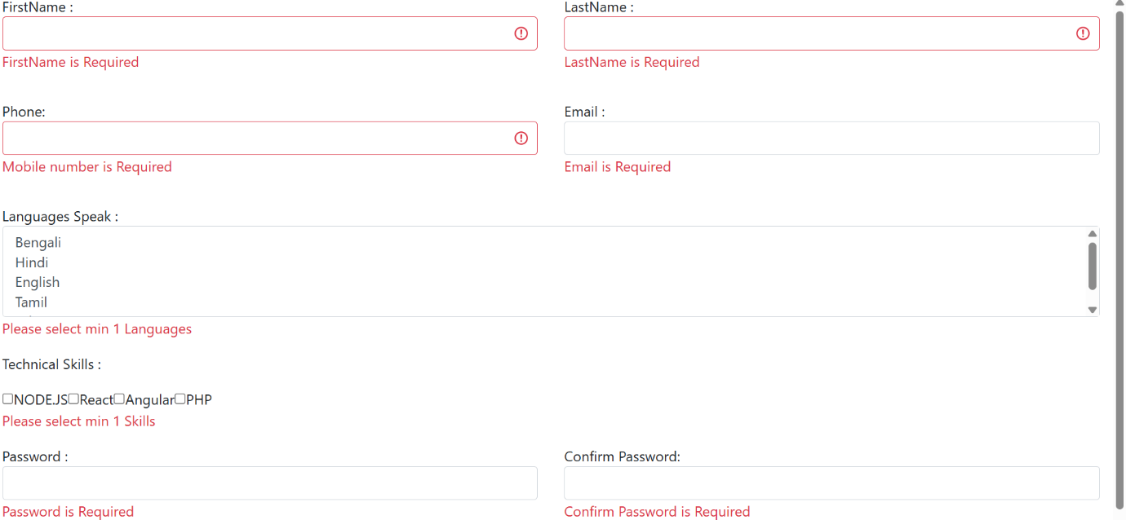
Done!

